Treasure Trove

Problem Description

There is a maze of N x N size, each element will have an alphabet from ‘A’ to ‘Z’. (for ease of calculation N is odd). ‘T’ represents Treasure, X represents the passage. The treasure is placed at the center of the maze (e.g. for a 5 x 5 maze, treasure is at 3rd row & 3rd Column). Only way to reach the treasure is from the top left corner of the maze & the entry is allowed to next layer only if top left corner has passage ( ‘X’ ). Your aim is to find the minimum number of steps at each layer of the maze to be rotated counter clockwise ( +ve) /clockwise ( -ve) so that all ‘X’ come to the left corner & treasure can be reached.

E.g.

The input Maze is as given in the below image.

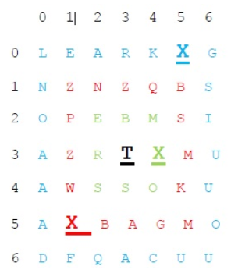

First layer is the text mentioned in Blue colour.

Second layer is the text mentioned in Red colour.

Third layer is in Green colour.

'T’ is the treasure and 'X' is the passage.

To reach the Treasure from top left, You need to rotate first layer counter clockwise 5 times, Red layer Clock wise 4 times (so -4), and Green one by ‘3’ counter clockwise. This makes ‘X’ in first layer to reach (0,0) position, (1,1) position & (2,2) position.

It is guaranteed that only one ‘X’ is present in each of the layer.

Constraints

5 <= N <= 1000

Input Format

First line contains an integer N (size of matrix).

Next N lines contain N characters separated by space denoting the matrix.

Output

First line should contain no. of rotations (+ve for counter clockwise and -ve clockwise) for each layer. (If both are equidistant rotate it counter clockwise(+ve output).

Next N lines must contain the resultant maze after transformations.

Test Case

Explanation

Example 1

Input

5

O I M U R

J V U X A

X W T S R

K Z F H D

Q W K V M

Output

-2 2

X J O I M

K X S H U

Q U T F R

W V W Z A

K V M D R

Example 2

Input

7

L E A R K X G

N Z N Z Q B S

O P E B M S I

A Z R T X M U

A W S S O K U

A X B A G M O

D F Q A C U U

Output

5 -4 3

X G S I U U O

K X W Z P Z U

R B X O S N U

A A M T S Z C

E G B E R Q A

L M K M S B Q

N O A A A D F

## Minimum Queens

### Problem Description

Imagine a chess board of size N x N where M Queens are placed on the chess board at different squares (i, j) where i is the row and j is the column. Pick a queen that can attack maximum other queens. If a queen is attacked it goes off the board. Minimize number of queens that remain on the board.

A Queen can move diagonally, horizontally and vertically.

A Queen can be moved only to attack another Queen and the path completes once this Queen cannot attack any other Queen on the board

Your aim is to print the minimum number of Queens that can remain on the board after choosing one path.

### Constraints

3 <= N <= 50 1 <= M <= (N*N)

### Input Format

First line contains two integers, N (size of board) and M (number of queens) delimited by comma (,)

Next M Lines, contain two integers and a string representing the coordinates of the position of queens and the name of the queen. For example 8,8,Q1, Here 8,8 is the position of Q1.

Refer diagrams in Example section for understanding the coordinate system of the board. Top left corner of the board is (1, 1) and bottom right is (N, N).

### Output

One line containing minimum number of Queens that can remain on the board after all the possible attacks in one path are completed

### Test Case

### Explanation

Example 1

Input

8,9 8,8,Q1 8,5,Q2 7,6,Q3 6,3,Q4 5,1,Q5 3,3,Q6 3,8,Q7 2,7,Q8 1,4,Q9

Output

2

Explanation

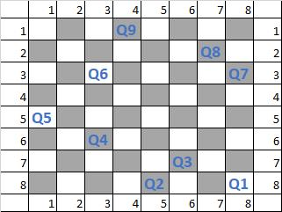

There are total 9 Queens in the given scenario. **If you pick Q1,** It can kill 2 queens, if Path#1 (Q1 ==> Q6 ==> Q5) is followed It can kill 5 queens, if Path#2 (Q1 ==> Q7 ==> Q6 ==> Q4 ==> Q2 ==> Q3) is followed **If you pick Q3,** It can kill 7 queens, if Path#3 (Q3 ==> Q2 ==> Q1 ==> Q7 ==> Q8 ==> Q4 ==> Q6 ==> Q5) is followed Similarly, there can arise 'n' number of different paths if different Queens are chosen. The best path here is Path#3 that can kill 7 Queens & leaves only 2 queens on the board. So, 2 is the answer.

Input

8,6 8,8,Q1 8,5,Q2 7,6,Q3 5,1,Q6 3,1,Q5 1,3,Q4

Output

4

Explanation

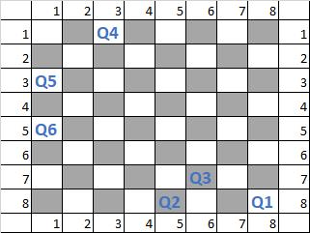

Path#1 - Q1 -> Q2 -> Q3 Path#2 - Q4 -> Q5 -> Q6 But not both of them. After choosing either of the path, 1 + 3(from other path) remain on the table. So Answer here is 4.

## Dining Table

### Problem Description

In a conference, attendees are invited for a dinner after the conference. The Coordinator, Sagar arranged round tables for dinner and want to have an impactful seating experience for the attendees. Before finalizing the seating arrangement, he want to analyze all possible arrangements. There are R round tables and N attendees. In case where N is an exact multiple of R, the number of attendees must be exactly N/R. If N is not an exact multiple of R, then the distribution of attendees must be as equal as possible. Please refer Example section for better understanding.

For example, R =2 and N=3

All possible seating arrangements are  
(1,2) & (3)  
(1,3) & (2)  
(2,3) & (1)  
Attendees are numbered from 1 to N.

### Constraints

0 < R <= 10 (Integer)

0 < N <= 20 (Integer)

### Input Format

One line containing two space delimited integers R and N, where R denotes the number of round tables and N denotes the number of attendees

### Output

Single integer S denoting number of possible unique arrangements

### Test Case

### Explanation

Example 1

Input

2 5

Output

10

Explanation

R=2, N=5  
  
1. (1,2,3) & (4,5)  
2. (1,2,4) & (3,5)  
3. (1,2,5) & (3,4)  
4. (1,3,4) & (2,5)  
5. (1,3,5) & (2,4)  
6. (1,4,5) & (2,3)  
7. (2,3,4) & (1,5)  
8. (2,3,5) & (1,4)  
9. (2,4,5) & (1,3)  
10. (3,4,5) & (1,2)  
  
Arrangements like  
(1,2,3) & (4,5)  
(2,1,3) & (4,5)  
(2,3,1) & (4,5), etc.  
But, as it is a round table, all the above arrangements are same

## Attendees Count

### Problem Description

A Seminar is organised by XYZ company for it’s employees. After the seminar, refreshments are served. There are three queues, one each for Juice, Cut fruits and Sandwich. Employees can go wherever they want and pick any snack item(s) in following fashion

· An employee can go for any snack any number of times as desired.

· S/he can move to another queue upon collecting snack from current queue (if s/he wants.)

For example, employee E, can first queue up for Sandwich and later queue up for Juice. After that E can queue up for sandwich again followed by cut fruits. If E is still hungry, then E can join any of the queues again.

Now, organisers want to ascertain that guests are well served. For this, they want to know the count of attendees, who have taken at least one snack in a particular interval of time. Now, there is no systematic way to do this, hence three different members of organizing team are watching the three different queues. Due to limitations of human memory, they are only able to watch sub-parts of the queue. They will collate their data and estimate the count of attendees who have taken at least one snack.

Their strategy is to randomly pick the lower and higher indices in each queue and memorize which guests were queued up in that sub-part. So for 3 queues, they would have 3 different observations. Note, that this is a mental exercise, hence their observations may collide on time. Simply put, the same employee may be seen in more than one queue, because their observations are not necessarily simultaneous.

Note : if an employee takes more than one snack then he/she will be counted as one.

### Constraints

0 < N <= 5000 (Integer)

0 < Employee ID <= 5000 (Integer)

0 < R <= 100000 (Integer)

### Input Format

First line contains an integer N, which denote the size of all 3 queues

Next three lines contain N space separated integers, which denote Employee IDs

Next line contains integer R, which denotes the number of queries

Next R lines containing 6 space separated integers L1,H1,L2,H2,L3,H3, where

L1 and H1 denote low and high indices of queue 1 i.e sub-part of queue 1

L2 and H2 denote low and high indices of queue 2 i.e sub-part of queue 2

L3 and H3 denote low and high indices of queue 3 i.e sub-part of queue 3

### Output

For each query, print the employee count who has had at least one snack, on a new line

### Test Case

### Explanation

Example 1

Input

10

11 12 13 14 15 16 17 18 19 20

16 17 18 19 20 21 22 23 24 25

21 22 23 24 25 26 27 28 29 30

1

2 7 1 5 2 6

Output

14

Explanation

We can see that there is only one query. So we have to get 2nd to 7th employee from the first queue, which is 12 13 14 15 16 17. Similarly, 1st to 5th employee from the second queue, which is 16 17 18 19 20. Finally, 2nd to 6th from the third queue, which is 22 23 24 25 26.

So now the final list contain :

12 13 14 15 16 17 16 17 18 19 20 22 23 24 25 26

But we can see that employee with Employee ID 16 17 are coming twice in the list. So we count them only once so the final Employee count is 14.

Example 2

Input

7

1 2 3 4 5 6 7

6 6 2 1 5 2 1

2 5 4 3 1 8 3

2

1 5 3 5 2 4

1 3 5 6 3 7

Output

5

6

Explanation

For 1st query 1 5 3 5 2 4

For the first query we have to get 1st to 5th employee from the first queue, which is 1 2 3 4 5. Similarly, 3rd to 5th employee from the second queue, which is 2 1 5. Finally, 2nd to 4th from the third queue, which is 5 4 3.

So now the final list contain :

1 2 3 4 5 2 1 5 5 4 3

But we can see that employee with Employee ID 1 2 3 4 5 are coming twice in the list. So we count them only once so the final Employee count is 5.

Similarly For 2nd record 1 3 5 6 3 7 output will be 6.

## Two Circles

### Problem Description

There are 2 circles, of possibly varying sizes, which rotate in clock-wise direction. *A* is a point of interest on first circle and *B* is a point of interest on second circle. Radius of first circle is always less than or equal to radius of second circle. The two circles are initially, D distance apart. After rotations, their distance becomes D*. On second circle, *C* is a point diametrically opposite to point *B*. Given this geometry, find angle between AB and AC, that is angle BAC.

Refer figures in Examples section for a better understanding of the problem.

Please note the images are not to scale. They are intended to depict only the geometry.

### Constraints

1 <= R1 <= 10^5

1 <= R2 <= 10^5

0.0 <= D <= 10000.0

0<= X1 <= 100

0<= X2 <= 100

### Input Format

First line contains 5 space delimited values denoted by R1 R2 D X1 X2

where,

R1 is an integer and denotes the radius of the first circle

R2 is an integer and denotes the radius of the second circle

D is the initial distance between the two circles and is a real number

X1 is an integer and denotes number of 90-degree rotations in clock-wise direction, done by the first circle

X2 is an integer and denotes number of 90-degree rotations in clock-wise direction, done by the second circle

### Output

Angle between AB and AC, that is Angle BAC accurate upto 6 digits after decimal point. Angle should be in degrees.

### Test Case

### Explanation

Example 1

Input

1 10 5 4 3

Output

5.436806

Explanation

Initial position of the point A and B

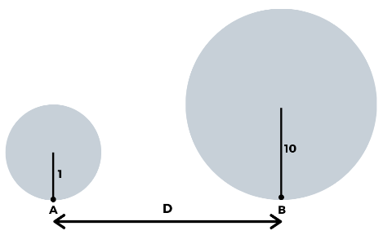

Position after four 90-degree rotations of circle one and three 90-degree rotations of circle two

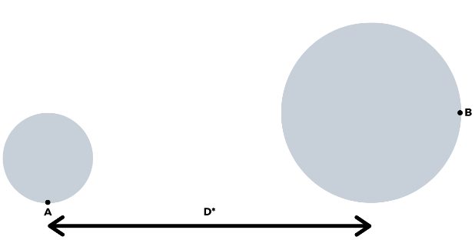

C is the diametrically opposite of B, depicted by dotted line. Find angle between AB and BC, that is angle BAC

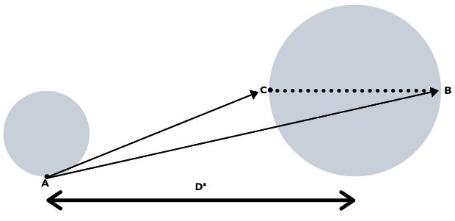

Angle between AB and AC is 5.436806 degrees

Example 2

Input

2 2800 70 79 12

Output

6.077228

Explanation

Initial position of the point A and B

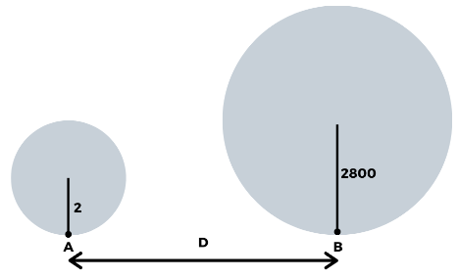

Position after seventy-nine 90-degree rotations of circle one and twelve 90-degree rotations of circle two

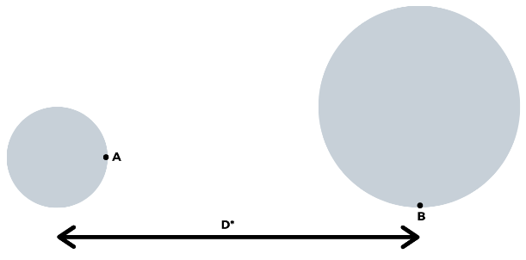

C is the diametrically opposite of B, depicted by dotted line. Find angle between AB and BC, that is angle BAC

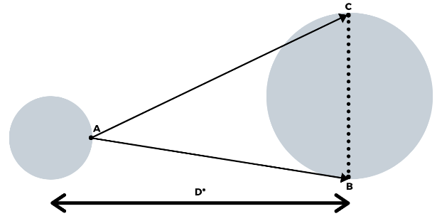  
Angle between AB and AC is 6.077228 degrees

## Glass Piece

### Problem Description

A square glass sheet of size 'S' cm fell down and broken down into N+1 pieces.

A man collected the broken pieces and he is trying to arrange the pieces to get the original shape. He found that exactly one piece is missing. To find the exact position of the missing piece, he noted down all (x,y) coordinates of each broken piece. Please help him to find the coordinates of the missing piece.

Note 1 : The input order of corners of known glass pieces are in the clockwise direction starting from the corner having least X value. If more than one corners having the same least X value, then start from the corner having least X and least Y value.

Note 2 : The corners of missing glass piece should output in the clockwise direction starting from the corner having least X value. If more than one corners have same least X value, then start from the corner having least X and least Y value.

### Constraints

1 < S <= 1000.

1 < N <= 50.

### Input Format

First line contains an integer, S, size of Glass Sheet.

Second line contains an integer, N.

Next N lines contain set of space separated integers indicates the details of N known glass pieces as follows:

· First number indicates total corners of that glass piece - say i,

· followed by 2 * i integers denotes X and Y coordinates of i corners, delimited by space

### Output

Coordinates of missing piece in (X,Y) format separated by spaces.

### Test Case

### Explanation

Example 1

Input

400

3

5 0 0 200 0 400 200 100 250 0 250

3 200 0 400 0 400 200

4 100 250 400 200 400 400 200 400

Output

(0,250) (100,250) (200,400) (0,400)

Explanation

The size of the square glass plate is 400 cm * 400 cm. The glass plate broke into 4 pieces and he got 3 pieces.

He placed first glass piece as below figure:

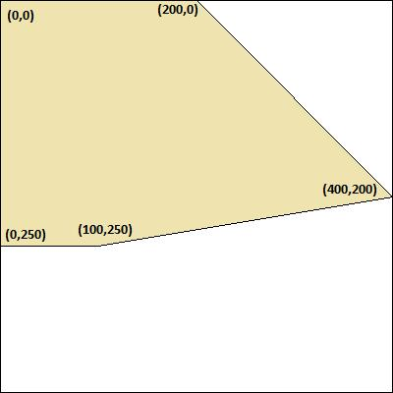

Figure. 1

Next he placed second glass piece as below figure:

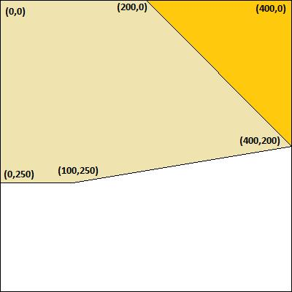

Figure. 2

Next he placed third glass piece as below figure:

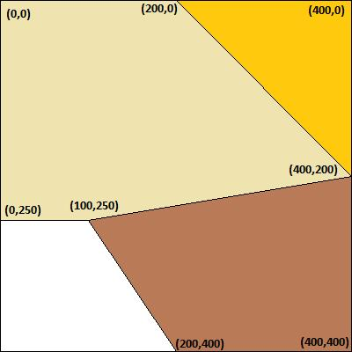

Figure. 3

Finally he found the position of the missing piece as below figure:

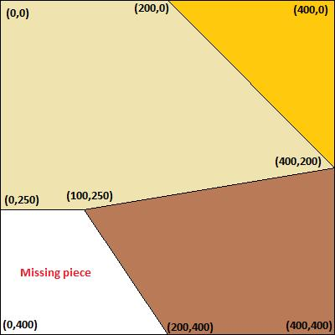

Figure. 4

Lastly, display the coordinates of missing glass piece in the clockwise direction starting from the corner (0,250), as output.

## Friend Circle

### Problem Description

2N friends (A,B,C... , 2N) are standing in a circle. There is exactly one person standing opposite of one other person. Some of them are facing inwards and some of them are facing outwards. Here given some facts your task is to build the standing positions and answer a few Questions. If the arrangement is not possible or more than one arrangement is possible, then print "ARRANGEMENT NOT POSSIBLE". The formats of *Facts* & *Questions* and its meanings are as follows. **Facts** "1AB" means : A and B are standing adjacent to each other "2AB" means : A and B are standing opposite to each other "3AB" means : A is standing to the immediate left of B  "4AB" means : A is standing to the immediate right of B "5A" means : A is facing inwards "6A" means : A is facing outwards "7n" means : n people are facing inwards, where n is a number "8n" means : n people are facing outwards, where n is a number

**Questions** "?2A" means : who is standing opposite of A? '?3A" means : who is standing to the immediate left of A? "?4A" means : who is standing to the immediate right of A? "?5A" means : is A facing inwards? Ans:Y/N "?6A" means : is A facing outwards? Ans:Y/N

### Constraints

1 < N < 10

1 < Total Facts < 30

1 < Total Questions < 20

### Input Format

N Multiple facts, separated by semicolon multiple questions, separated by semicolon

### Output

Answers, separated by semicolon corresponding to order of questions OR "ARRANGEMENT NOT POSSIBLE"

### Test Case

### Explanation

Example 1

Input

2 2AB;72;1AC;6D;4BD;6C ?2D;?3C;?4B;?5A;?6B

Output

C;B;D;Y;N

Explanation

4 people- A, B, C and D are standing in circle.  There are 6 facts separated in semicolons: 2AB ==> A and B are standing opposite 72 ==> 2 people are facing inwards 1AC ==> A and C are standing nearby 6D ==> D is facing outwards 4BD ==> B is standing immediate right of D 6C ==> C is facing outwards From the above facts, we can build the standing positions as below image:

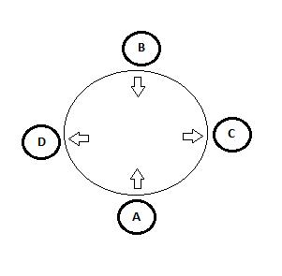

There are 5 questions: ?2D ==> who is standing opposite of D? Ans:C ?3C ==> who is standing immediate left of C? Ans:B ?4B ==> who is standing immediate right of B? Ans:D ?5A ==> is A facing inwards? Ans:Y ?6B ==> is B facing outwards? Ans:N Finally printing all answers in a single line separated by semicolon.

Example 2

Input

2 4BA;3CA;3CD;5C;5B ?5A;?3D;?4C;?6B

Output

ARRANGEMENT NOT POSSIBLE

Explanation

We can arrange 4 people in two different ways as the image below, from the facts provided. Directions of A and D can be set differently.

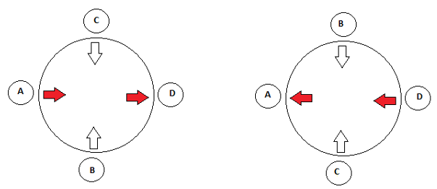

## Home Lighting

### Problem Description

You are moving to a new apartment and want to plan your total lighting cost for the next 2 years which includes the cost of bulb procurement and cost of electricity consumption. Three types of bulbs are available in the market.

  1. Regular bulbs, which cost C1, have a warranty of M1 hours, and have a running cost of R1 per hour  2. CFL bulbs, which cost C2, warranty M2 hours, running, cost R2 per hour  3. LED bulbs, which cost C3, warranty M3 hours, running cost R3 per hour  C1 < C2 < C3 and R1 > R2 > R3, nothing can be said about M1, M2, and M3.  You have a plan for 1 bulb in the kitchen at H1 hours per day, 2 bulbs per room across 3 rooms at H2, H3, H4 hours per day per room per bulb, 1 bulb for bathroom at H5 hours per day.  When you prepare your budget, assume that it will last only until the warranty period.  Given the above requirements, come up with a bulb procurement plan that incurs least cost over 2 years - where cost includes procurement and running cost. In case warranty expires, in your model assume that the bulb will need to be replaced. Also, assume that you will move out after 2 years, and so you are not concerned about stretching the life of bulbs beyond that time. Assume that there are 365 days in each year.

### Constraints

C1 < C2 < C3

R1 > R2 > R3

0<= Fixed Cost <=1000

0<= Warranty<=30000

0<= Running cost <= 150

0<= H1,H2,H3,H4,H5<=24

### Input Format

The first three lines contains three integers denoting Fixed cost, Warranty and running cost of regular bulb, CFL and LED respectively.

The next five lines contain one integer each denoting usage hours of rooms (H1, H2, H3, H4, H5)

### Output

Minimum cost to light the house.

### Test Case

### Explanation

Example 1

Input

50 1500 16

100 8000 14

400 25000 1

1

2

8

14

2

Output

38500

Explanation

Minimum cost for meeting all the lighting requirement of house is 38500.

Example 2

Input

50 10000 16

100 8000 14

800 25000 1

2

6

10

8

1

Output

41960

Explanation

Minimum cost for meeting all the lighting requirement of house is 41960.